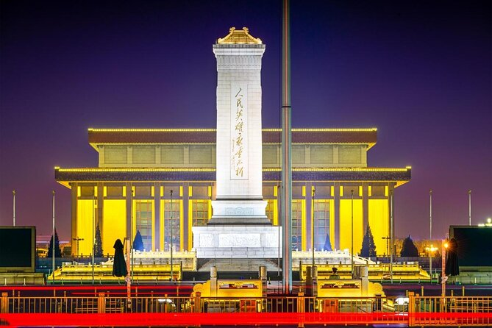

**Tiananmen Square**

Tiananmen Square is one of the most iconic and historically significant public spaces in the world. Located in the heart of Beijing, the capital city of China, this vast plaza covers an area of about 109 acres (44 hectares) and holds immense cultural, political, and symbolic importance for the Chinese people.

The square's name, "Tiananmen," translates to "Gate of Heavenly Peace," referring to the monumental Tiananmen Gate, which stands on the northern end of the square. The gate is an essential part of the Forbidden City, the imperial palace complex that once served as the residence of Chinese emperors during the Ming and Qing dynasties.

Throughout history, Tiananmen Square has witnessed numerous significant events, both celebratory and tragic. It has been a gathering place for imperial ceremonies, cultural festivals, and other public occasions. However, one event

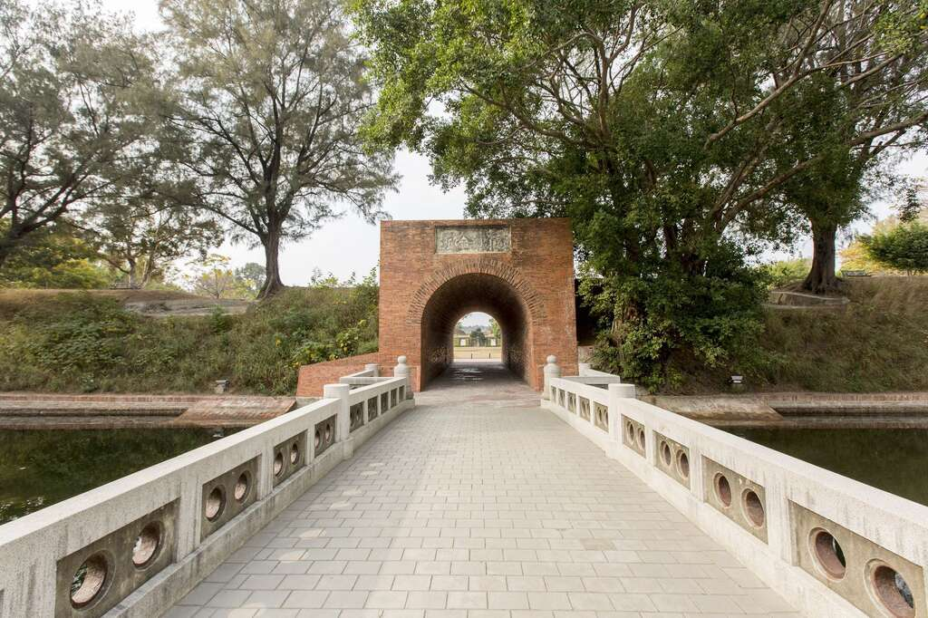

**Eternal Golden Casle**

As of my last update in September 2021, there is no widely known or recognized place called the "Eternal Golden Castle." It's possible that such a place may have gained prominence or become known by another name after my last update.

If the Eternal Golden Castle is a fictional location or a concept from a book, movie, or other creative work, I won't have any information on it beyond my last update in 2021.

If you are referring to a different place or have more context about the Eternal Golden Castle, please provide additional information, and I'd be happy to help with any relevant details or explanations.

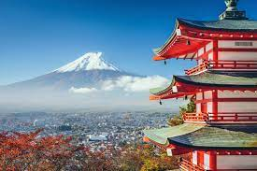

**Mount Fuji**

Mount Fuji, or Fuji-san in Japanese, is an iconic and majestic stratovolcano located on the main island of Honshu, Japan. Standing at an impressive height of 3,776.24 meters (12,389 feet), it is the highest peak in the country and has long been revered as a symbol of Japan's natural beauty and cultural heritage.

The mountain's perfectly symmetrical cone shape and snow-capped peak have inspired artists, poets, and travelers for centuries. Its beauty has earned it the nickname "Fuji no Taka" or "Fujisan" (Mount Fuji) in Japanese, which translates to "Never-Dying Bird" due to its stunning, enduring presence.

Mount Fuji has played a significant role in Japanese culture, spirituality, and art. It has been depicted in countless traditional woodblock prints, paintings, and poems throughout history. Pilgrims have been ascending the mountain for centuries, seeking spiritual enlightenment and connecting with nature.

Climbing Mount Fuji is a popular activity during the summer months (July to early September) when the weather is most favorable. The climbing season attracts both locals and international tourists, and there are several well-

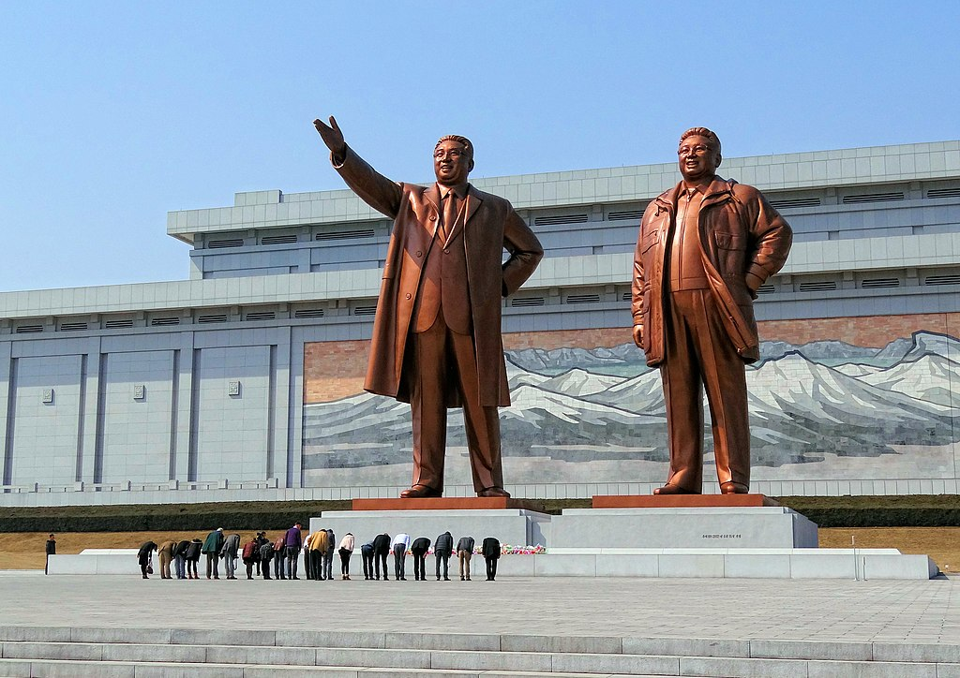

**Mansu Hill Garden**

Mansu Hill Garden, also known as Mansudae Park, is a significant public park located in the heart of Pyongyang, the capital city of North Korea. The garden is a vast complex that features numerous statues, monuments, and green spaces, making it one of the prominent landmarks in the city.

At the center of Mansu Hill Garden stands the grand Mansudae Grand Monument, a bronze statue of North Korea's founding leader, Kim Il-sung, and his son and successor, Kim Jong-il. The statues are imposing and iconic, with Kim Il-sung portrayed in a confident posture, and Kim Jong-il standing beside him. The monument, completed in 1972, serves as a symbol of the country's leadership and a place of reverence for the people of North Korea.

.

Top of Form

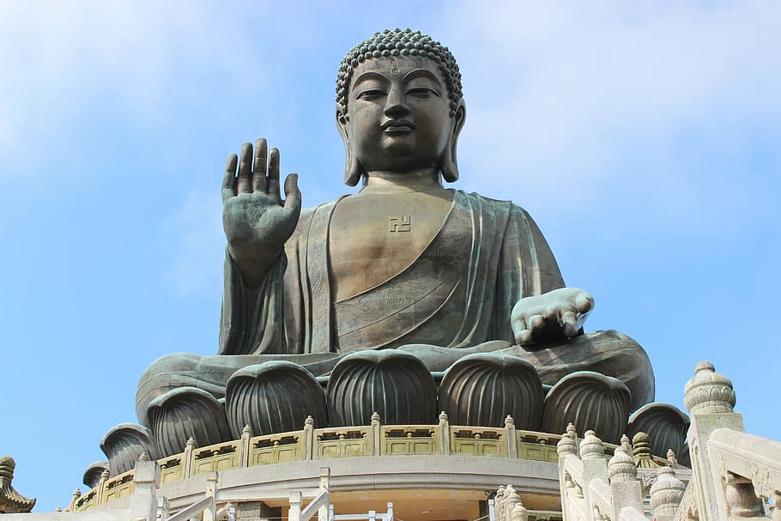

**Tian tan buddah**

Tian Tan Buddha, also known as the Big Buddha, is a massive bronze statue of Buddha Shakyamuni located on Lantau Island in Hong Kong. It is one of the most significant religious and cultural landmarks in the region and a popular tourist attraction that draws visitors from all over the world.

The construction of Tian Tan Buddha began in 1990 and was completed in 1993. The statue stands at an impressive height of 34 meters (112 feet) and weighs about 250 metric tons. It is positioned atop a hill at Ngong Ping, facing north, and overlooks the picturesque landscapes of Lantau Island.

To reach the Big Buddha, visitors have the option to hike the scenic Ngong Ping Trail or take a 25-minute cable car ride on the Ngong Ping 360, offering breathtaking views of the island's lush greenery and surrounding waters.

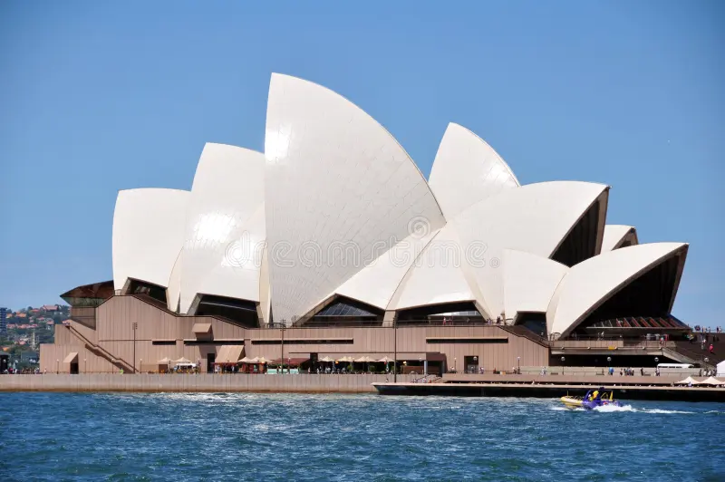

**Sudney Opera House**

The Sydney Opera House is an iconic architectural masterpiece and one of the most recognizable landmarks in the world. It is situated on Bennelong Point in Sydney, Australia, overlooking the stunning Sydney Harbour and the Sydney Harbour Bridge. Designed by Danish architect Jørn Utzon, this unique building has become a symbol of Australia's cultural identity and a UNESCO World Heritage Site.

Construction of the Sydney Opera House began in 1959 and was completed in 1973. The project was a significant engineering challenge due to its groundbreaking design, which features a series of interlocking sail-like shells that form the roofs of the main performance halls.

The Opera House consists of multiple performance venues, making it a hub for the arts and entertainment in Australia. The main concert hall, known as the

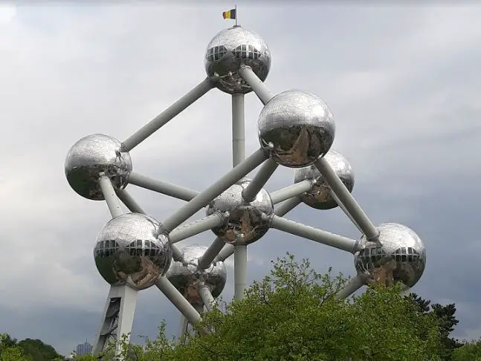

**The Mannken Pis**

The Manneken Pis, also known as "Petit Julien," is a famous and quirky bronze statue located in the heart of Brussels, the capital city of Belgium. The statue depicts a little boy urinating into a fountain basin, and it has become one of Brussels' most beloved symbols and a popular tourist attraction.

The origins of the Manneken Pis date back to the early 17th century, although the exact date of its creation is uncertain. The statue has undergone several replacements and restorations over the centuries, but its playful and mischievous charm remains unchanged.

The Manneken Pis stands at a height of approximately 61 centimeters (24 inches) and is usually adorned with various costumes and outfits, often reflecting special occasions, cultural events, or national celebrations. These costumes are carefully curated and maintained by the non-profit organization called "The Friends of Manneken Pis," ensuring that the statue is always dressed in style.

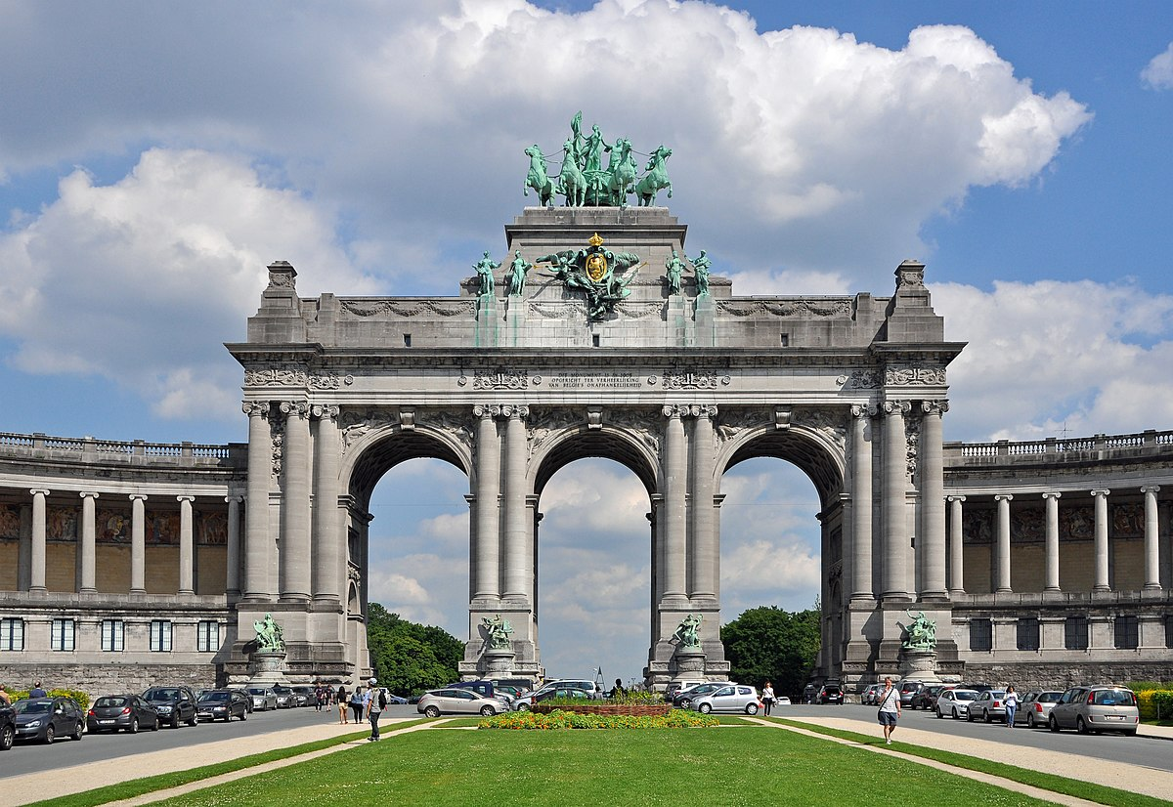**Cinquantenaire** Arcade

As of my last update in September 2021, there is no widely known or recognized landmark called the "Cinquantenaire Arcade." It's possible that such a place may have gained prominence or been established after my last update.

If the Cinquantenaire Arcade is a fictional location or a concept from a book, movie, or other creative work, I won't have any information on it beyond my last update in 2021.

If you are referring to a different place or have more context about the Cinquantenaire Arcade, please provide additional information, and I'd be happy to help with any relevant details or explanations.

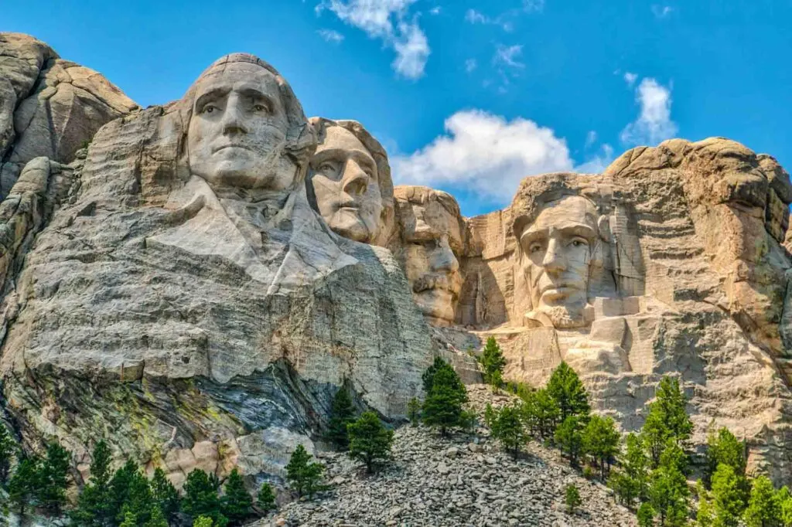

**Mount Rushoom**

Mount Rushmore is a famous landmark located in the Black Hills of South Dakota, United States. It is renowned for its monumental sculpture of the faces of four iconic American presidents: George Washington, Thomas Jefferson, Theodore Roosevelt, and Abraham Lincoln. The sculpted faces are carved into the granite rock face of the mountain, creating an awe-inspiring tribute to these influential leaders of the United States.

The idea for creating Mount Rushmore as a national memorial was proposed by historian Doane Robinson in the early 1920s. The project was further developed and executed by sculptor Gutzon Borglum, who began work on the monument in 1927. The construction was a challenging task, with workers using dynamite, jackhammers, and hand tools to carve the colossal faces into the mountain.

Each president's face was carved to a height of about 18 meters (60 feet) and required meticulous precision to capture their distinct facial features and

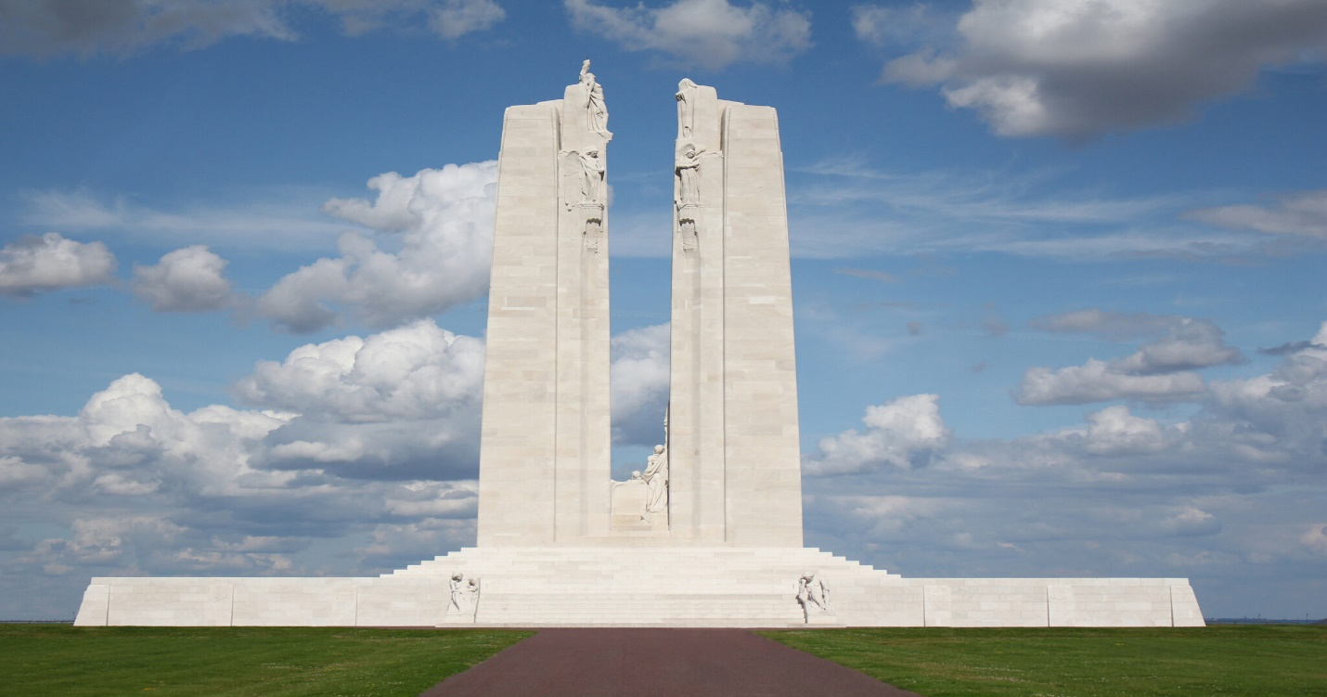

|  |
| --- |
| Top of Form |

**Vimy Memorial**

The Vimy Memorial, also known as the Canadian National Vimy Memorial, is a significant and iconic monument located in northern France, near the town of Vimy. It stands as a tribute to the Canadian soldiers who fought and lost their lives during World War I, specifically during the Battle of Vimy Ridge in April 1917.

The Battle of Vimy Ridge was a critical military engagement between the Canadian Corps and the German Army. For the first time during World War I, all four Canadian divisions fought together as a cohesive force, making a concerted effort to capture Vimy Ridge from the German forces.

The Vimy Ridge was a heavily fortified and strategically important position, offering the Germans a significant advantage in the ongoing conflict. Previous attempts by other Allied forces to capture the ridge had failed, resulting in significant casualties.

Under the leadership of General Arthur Currie, the Canadian forces meticulously planned and executed a complex assault that involved a

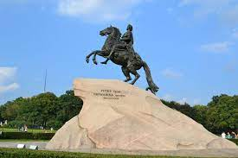

**Bronze horseman.**

The Vimy Memorial, also known as the Canadian National Vimy Memorial, is a significant and iconic monument located in northern France, near the town of Vimy. It stands as a tribute to the Canadian soldiers who fought and lost their lives during World War I, specifically during the Battle of Vimy Ridge in April 1917.

The Battle of Vimy Ridge was a critical military engagement between the Canadian Corps and the German Army. For the first time during World War I, all four Canadian divisions fought together as a cohesive force, making a concerted effort to capture Vimy Ridge from the German forces.

The Vimy Ridge was a heavily fortified and strategically important position, offering the Germans a significant advantage in the ongoing conflict. Previous attempts by other Allied forces to capture the ridge had failed, resulting in significant casualties.

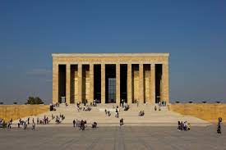

**Anitkabir turkey.**

Anıtkabir, also known as Atatürk's Mausoleum, is a significant and revered monument located in Ankara, the capital city of Turkey. It serves as the final resting place of Mustafa Kemal Atatürk, the founder and first President of the Republic of Turkey, who led the country through a period of sweeping reforms and modernization.

The construction of Anıtkabir began in 1944, two years after Atatürk's passing in 1938, and the mausoleum was officially inaugurated on August 9, 1953. The monument's design was the result of a national competition won by Turkish architect Emin Onat and Swiss architect Paul Bonatz. It is a massive and imposing structure, reflecting both classical and modern architectural styles.

Anıtkabir is situated on a hill in the Anıttepe neighborhood of Ankara, providing a commanding view of the city. The approach to the mausoleum is through a ceremonial road called the "Lions Road," lined with monumental statues of lions, symbolizing strength and bravery.

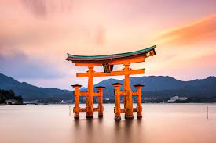

**Itsukushima japan.**

Itsukushima, also known as Miyajima, is a picturesque island located in the Seto Inland Sea of Japan. It is renowned for its stunning beauty, historical significance, and its iconic floating torii gate, which seems to stand magically in the water. Itsukushima is a designated UNESCO World Heritage Site and is considered one of Japan's most scenic spots.

Geographically, Itsukushima is part of the city of Hatsukaichi in Hiroshima Prefecture, southwestern Japan. The island is roughly 30 square kilometers in size and is characterized by its lush greenery, hilly landscapes, and traditional Japanese architecture.

The most famous and recognizable feature of Itsukushima is the Itsukushima Shrine, which was originally built in the 6th century. The shrine is unique in that it appears to float on the water during high tide due to the design of its wooden pillars. During low tide, visitors can walk up close to the torii gate and

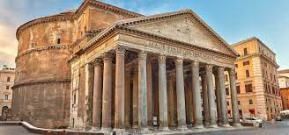

**Pantheon Italy.**

The Pantheon is an ancient Roman temple located in the heart of Rome, Italy. It is one of the most iconic and well-preserved buildings from ancient times and stands as a remarkable testament to Roman engineering and architecture. The term "Pantheon" translates to "all the gods" in Greek, reflecting the temple's original purpose as a place of worship for a multitude of deities.

The history of the Pantheon dates back to 27 BC when the first version of the temple was commissioned by Marcus Agrippa, a Roman statesman and general, during the reign of Augustus. However, the original temple was destroyed by a fire in AD 80. The current structure that we see today was rebuilt by Emperor Hadrian between AD 118 and AD 128, making it over 1,900 years old.

The Pantheon's most distinctive feature is its massive and perfectly preserved dome. The dome has a diameter of approximately 43 meters (142 feet) and was the largest unreinforced concrete dome in the world until modern times. It is an architectural marvel, especially considering its age, and has influenced countless buildings and structures throughout history.

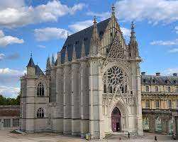

**Sainte chapelle paris**

Sainte-Chapelle, located in the heart of Paris, France, is a stunning Gothic chapel renowned for its exquisite stained glass windows and remarkable architectural design. It stands as a masterpiece of medieval architecture and a symbol of the French monarchy's power and religious devotion.

Construction of Sainte-Chapelle began in 1241 under the orders of King Louis IX (Saint Louis) to house precious Christian relics, including the Crown of Thorns believed to have been worn by Jesus Christ during his crucifixion. The chapel was intended to be a royal chapel within the Palais de la Cité, the residence of the French kings on the Île de la Cité, the historic center of Paris.

The chapel was completed in a relatively short period, with construction finishing around 1248. It consists of two levels: the lower chapel, dedicated to the Virgin Mary, and the upper chapel, reserved for the king and his court. The lower chapel, though less grand in scale, features beautiful frescoes and slender columns, creating an intimate and serene atmosphere.

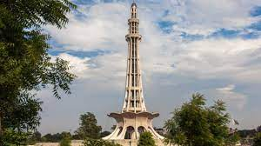

**Minar e PakistanTop of Form**

Minar-e-Pakistan, meaning "Tower of Pakistan" in Urdu, is a iconic monument located in Iqbal Park in Lahore, Pakistan. It holds immense historical and cultural significance as a symbol of Pakistan's struggle for independence and its formation as a sovereign nation.

The construction of Minar-e-Pakistan was initiated in the 1960s to commemorate the Lahore Resolution, also known as the Pakistan Resolution, which was passed on March 23, 1940. This resolution marked a pivotal moment in the history of British India when the All-India Muslim League formally demanded a separate nation for Muslims in South Asia. The resolution eventually led to the creation of the independent state of Pakistan in 1947.

The monument's design is a blend of modern and Islamic architectural styles, with strong influences from Mughal and Persian architecture. The tower itself is a soaring minaret, standing at a height of around 70 meters (230 feet). It consists of a base and a platform, and its unique shape reflects the four petals

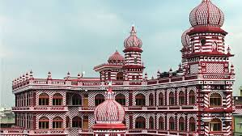

**Red mosque Sri Lanka.**

**As of my last knowledge update in September 2021, I don't have any information about a "Red Mosque" specifically in Sri Lanka. It's possible that this mosque has gained significance after my last update, or there might be a specific local name or context associated with it that I'm not aware of.**

**If you could provide more details or context about the "Red Mosque" you're referring to, I would be happy to help you with any information I can provide. Please feel free to share more details, and I'll do my best to assist you.**

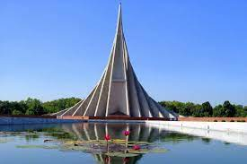

**National martyrs of Bangladesh**

The National Martyrs of Bangladesh, often referred to as the "Language Martyrs," hold a significant place in the history and identity of the country. Their sacrifice played a pivotal role in shaping the linguistic and cultural identity of Bangladesh.

The events leading to the recognition of the National Martyrs took place in 1952, shortly after the partition of India and the creation of Pakistan. The central issue at that time was the imposition of Urdu as the sole national language of Pakistan, disregarding the linguistic diversity of the country. This decision sparked protests and demonstrations, particularly in East Pakistan (now Bangladesh), where the majority spoke Bengali.

On February 21, 1952, students and activists took to the streets in Dhaka to protest against the imposition of Urdu and demand equal recognition for

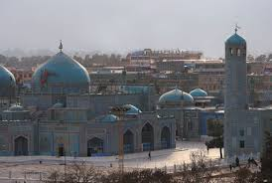

**Mazar sharif**

**Afghanistan.**

Mazar-i-Sharif, often simply referred to as Mazar, is a historically significant city in northern Afghanistan. It is the capital of Balkh Province and holds a special place in Afghan culture, history, and spirituality. The city is renowned for its historical sites, cultural heritage, and religious significance.

One of the city's most prominent landmarks is the Blue Mosque, also known as the Shrine of Hazrat Ali. This mosque is named after Hazrat Ali, the cousin and son-in-law of Prophet Muhammad in Islamic tradition. The mosque is known for its stunning blue-tiled exterior, which gives it its name. It is a place of worship, pilgrimage, and cultural significance for Muslims and Afghans alike.

Mazar-i-Sharif has been an important city for centuries, with a history dating back to ancient times. It was a significant center of trade and culture along the Silk Road, connecting various civilizations and influencing its development.

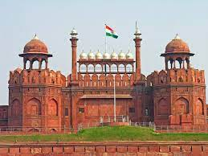

Top of Form

**Red fort india.**

**The Red Fort, known locally as "Lal Qila," is a UNESCO World Heritage Site located in the heart of Old Delhi, India. It stands as an iconic symbol of India's history, architecture, and cultural heritage. The fort is one of the most significant historical landmarks in the country and has played a central role in shaping India's past and present.**

**The construction of the Red Fort began in 1638 under the orders of the Mughal Emperor Shah Jahan. The fort was designed to serve as the main residence for the Mughal emperors of India. It took nearly a decade to complete, and the fort's distinctive red sandstone walls gave rise to its name. The fort's architecture is a blend of Persian, Indian, and Timurid styles, showcasing the artistic and cultural influences of the time.**

**The Red Fort covers a vast area and is surrounded by high walls, featuring impressive gates and watchtowers. The Lahori Gate, facing the city of Lahore, is the main entrance and welcomes visitors into the fort complex.**

**Inside the fort, visitors are treated to a series of palaces, pavilions, gardens, and courtyards that showcase the opulent lifestyle of the Mughal rulers. Some of the notable structures within the Red Fort include:**

**1. Diwan-i-Aam (Hall of Public Audience): This grand hall was where the emperor would address the public and listen to their grievances.**

**2. Diwan-i-Khas (Hall of Private Audience): A more intimate space where the emperor would meet with important officials and foreign dignitaries.**

**3. Rang Mahal (Palace of Colors): A palace with ornate decorations, including beautiful frescoes and intricate carvings.**

**4. Mumtaz Mahal: Named after Shah Jahan's beloved wife Mumtaz Mahal, this palace features an exquisite marble facade.**

**5. Khas Mahal: A private palace of the emperor characterized by its elegant architecture and marble detailing.**

**6. Hayat Bakhsh Bagh (Life-Bestowing Garden): A lush garden with fountains and water channels that provided respite from the bustling city.**

**The Red Fort is perhaps most famous for its annual celebration of India's Independence Day on August 15th. The Prime Minister of India hoists the national flag and addresses the nation from the ramparts of the fort, invoking a sense of national pride and unity.**

**Visitors to the Red Fort can explore its rich history, architectural beauty, and the significant role it played during India's Mughal era. The fort's stunning design, historical significance, and cultural value continue to captivate people from around the world, making it a must-visit destination in Delhi.**